Veterinary Equipment
Examination & Diagnostic Equipment

- Veterinary Stethoscope
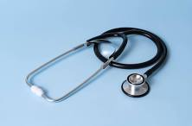

- Digital Veterinary Thermometer
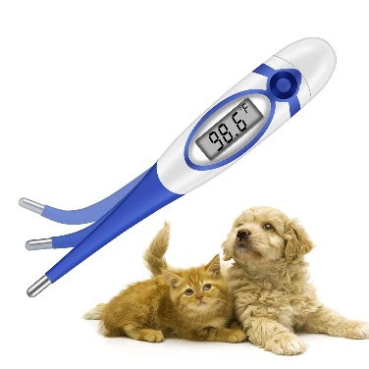

- Otoscope
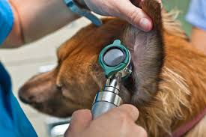

- Examination Table
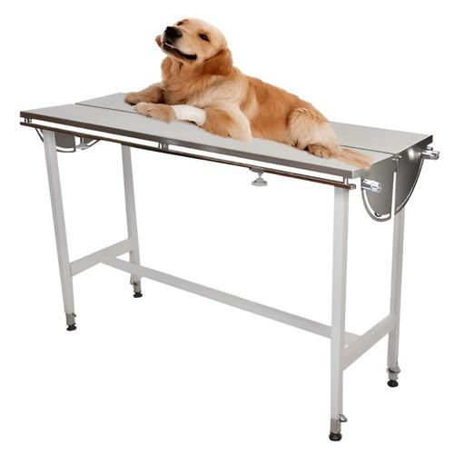

- Weighing Scale (Animal Scale)
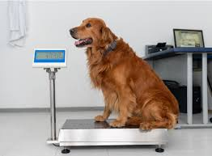

Surgical & Sterilization Equipment
- Surgical Instrument Set
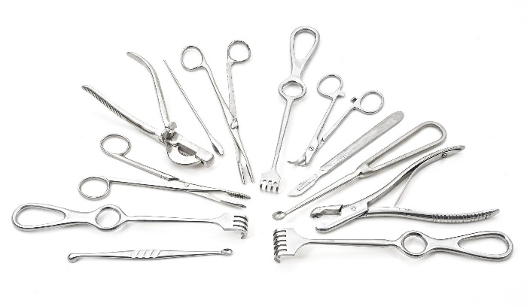
- Sterilizer
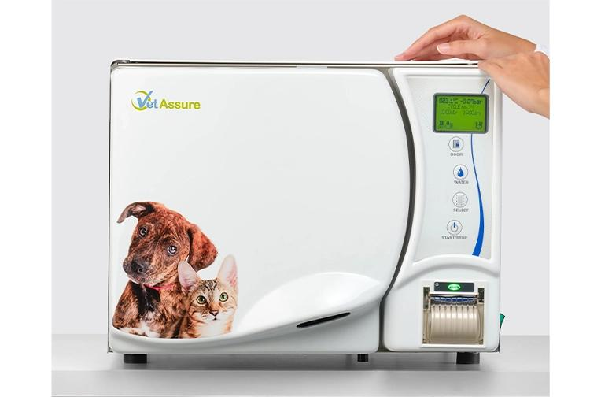

- Instrument Tray with surgical instruments
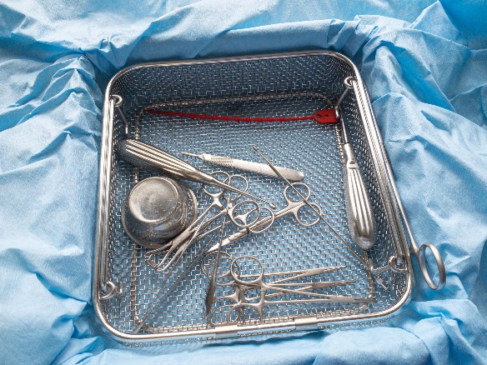

- Needle Holder
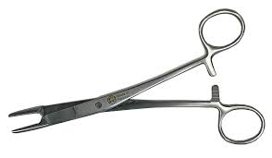

- Scalpel Handle and Blades

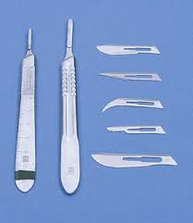

- Dressing Forceps

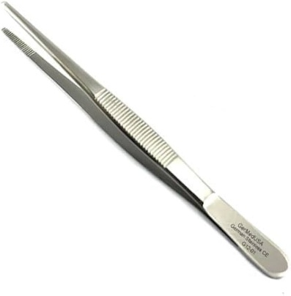

ANESTHESIA & EMERGENCY EQUIPMENT
- Oxygen Concentrator
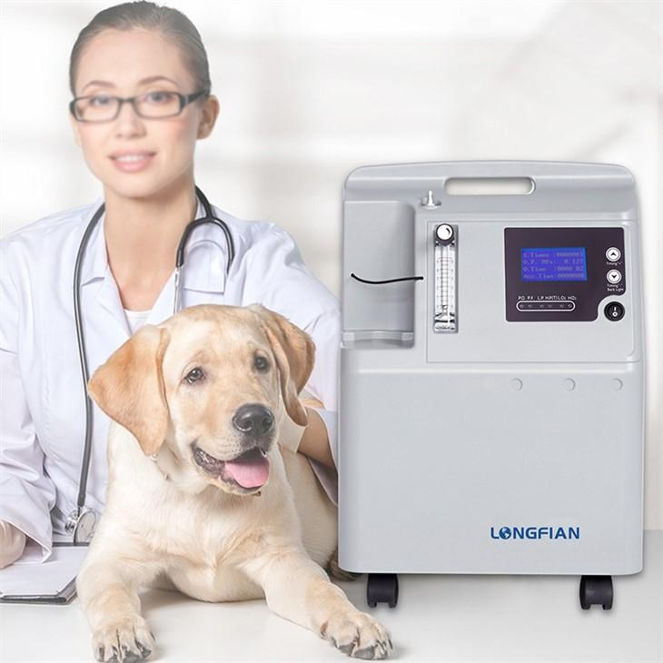
- Manual Resuscitator (Ambu Bag)
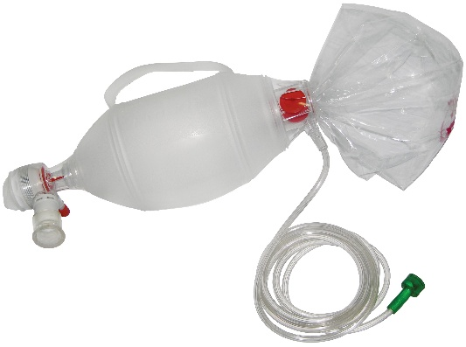

- Suction Machine
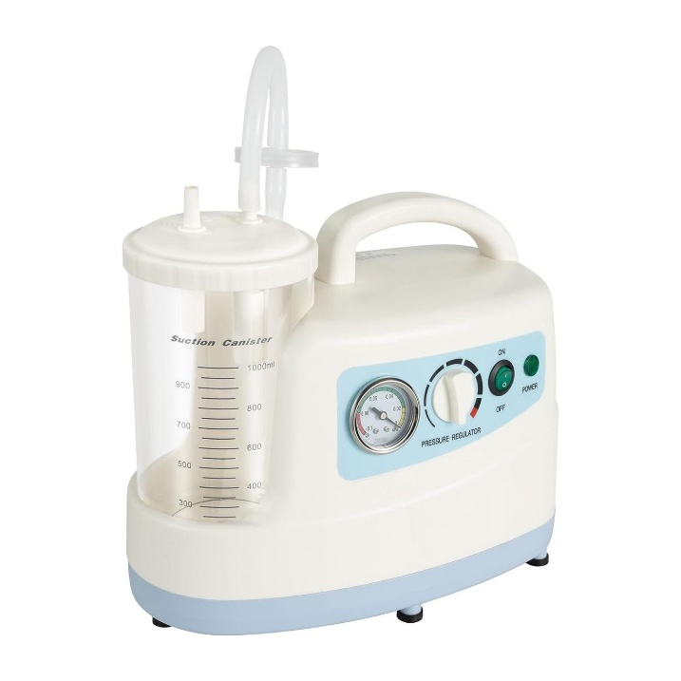

Large Animal / Field Veterinary Equipment
- Portable Ultrasound Scanner
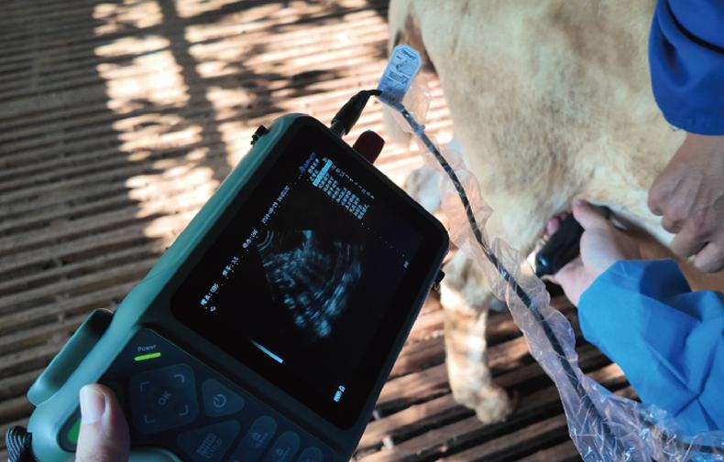

- Cow Hoof Trimming Equipment
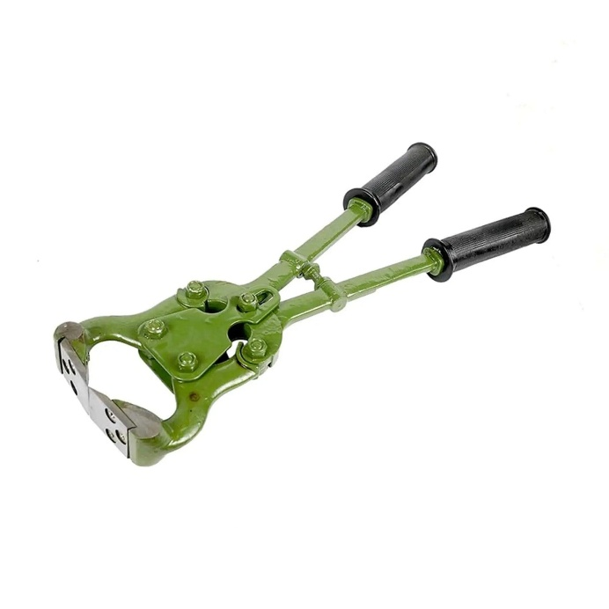
- Goat hoof trimmer

